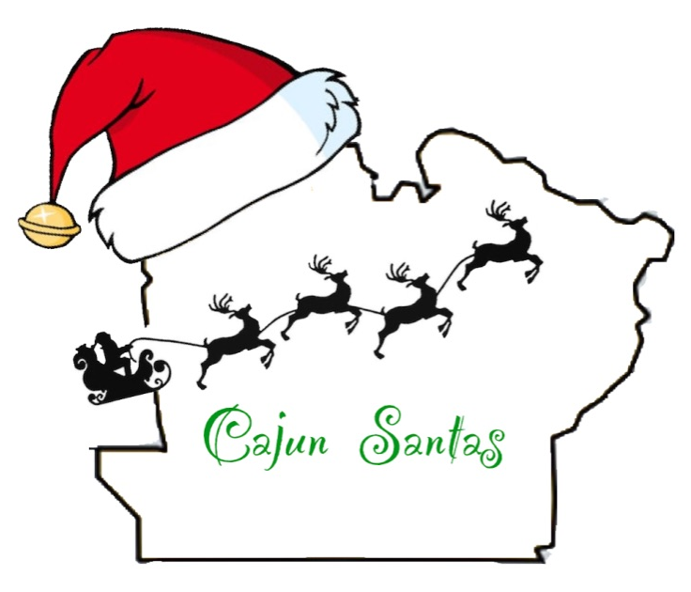
Cajun Santas
3646 Hwy 115
Hessmer, LA 71341
(318) 359-1046

Dear ,
Cajun Santas is a local non-profit organization founded in September 2019 to provide Christmas gifts for under-priviledged children in our communities. We are beyond excited to return this holiday season and continue our purpose. Our nonprofit is directed by a group of volunteers right here in Avoyelles. In December 2020, we hope to help numerous families here in Avoyelles Parish, putting a smile on their faces at Christmas.

One in four people in our parish are living in poverty and often times struggle to feed their families, much less be able to afford to brighten their Christmas with gifts. This statistic is the foundation on which this nonprofit was founded. We want to be able to help those children in need and simply let them know that people care about them. Last year we raised $16,000 to provide 46 children with a better Christmas, and the glow from these children’s faces was irreplaceable. During this time of COVID-19 where many families were faced with new or worsening financial struggles, our efforts are needed now more than ever.

Our main fundraiser this year will be a nighttime Christmas-themed 5K walk / run near Thanksgiving. We are seeking generous sponsors like you to make this charitable and gift giving event possible. Your sponsorship and donations will ensure that some children in Avoyelles will be blessed this Christmas season. Families will be chosen on a perceived need system so we can ensure that we help those families most in need this holiday season. Rest assured that your donations will go towards our effort of helping the children of this parish and that your donation is tax deductible.

We ask that you open your hearts and consider joining us in this tremendous movement. Attached you will find a sponsorship form that will need to be mailed back by November 1st to the above address.

Please do not hesitate to call, as I would love to talk with you about Cajun Santas’ plans and ideas. Thank you for your time and consideration in helping us make this a huge success.

Sincerely,

Jamie Ducote
Cajun Santas President

